Course _____12 Methods_____ Year __12___

Student name: ________________ Teacher name: ________________

Task type: Response

Time allowed for this task: ____40_______ mins

Number of questions: _____7______

Materials required: No calculators nor classpads

Standard items: Pens (blue/black preferred), pencils (including coloured), sharpener, correction fluid/tape, eraser, ruler, highlighters

Special items: Drawing instruments, templates, notes on one unfolded sheet of
A4 paper, and up to three calculators approved for use in the WACE examinations

Marks available: ___40___ marks

Task weighting: _10___%

Formula sheet provided: Yes

Note: All part questions worth more than 2 marks require working to obtain full marks.

Q1 (2, 3 & 3 = 8 marks) (3.1.7-3.1.8)
Determine for each of the following.(No need to simplify)

Q2 (2 & 3 = 5 marks) (3.1.8)
Consider .
- Determine

- Determine the equation of the tangent at

Q3 (1, 1, 3 & 3 = 8 marks) (3.1.7-3.1.8, 3.1.15)
Consider the following functions .
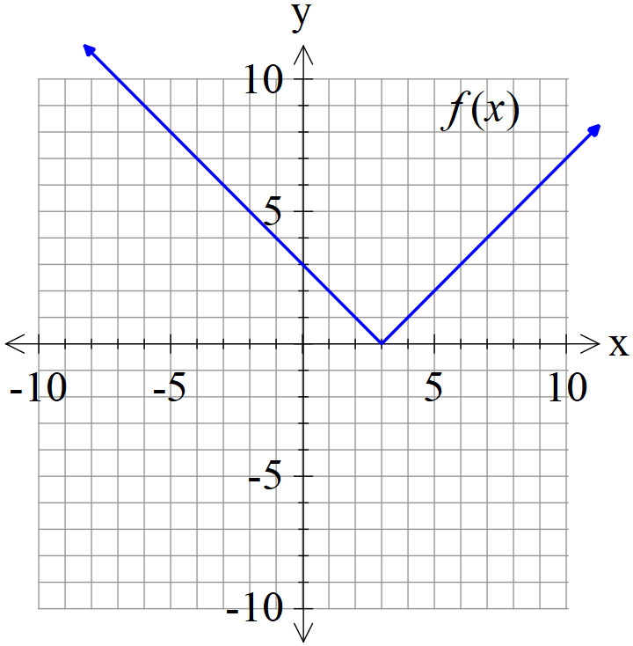 | 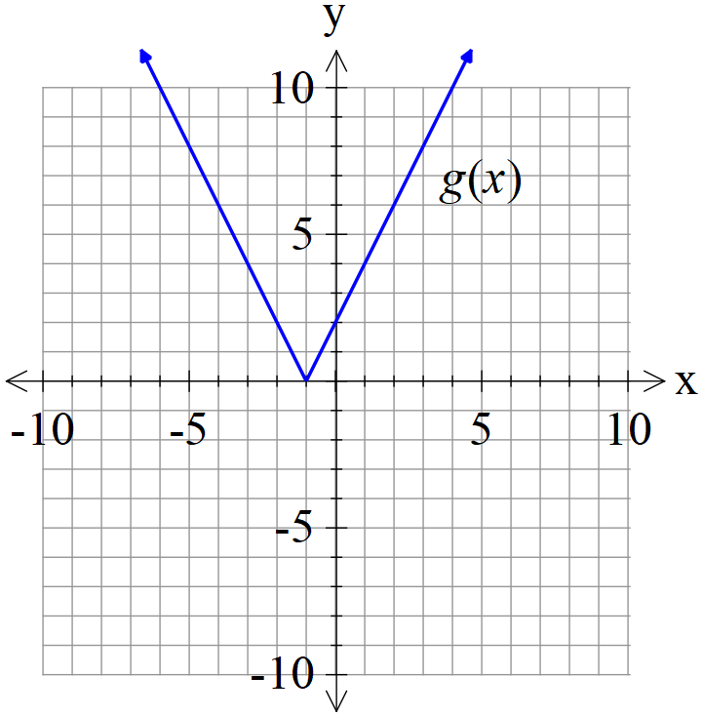

- Determine the derivative of when

- Determine the derivative of when

- Determine the derivative of when .

- Determine the derivative of when .

Q4 (2, 3 & 2 = 7marks) (3.1.13 – 3.1.17)
The following is the graph of , the derivative of .
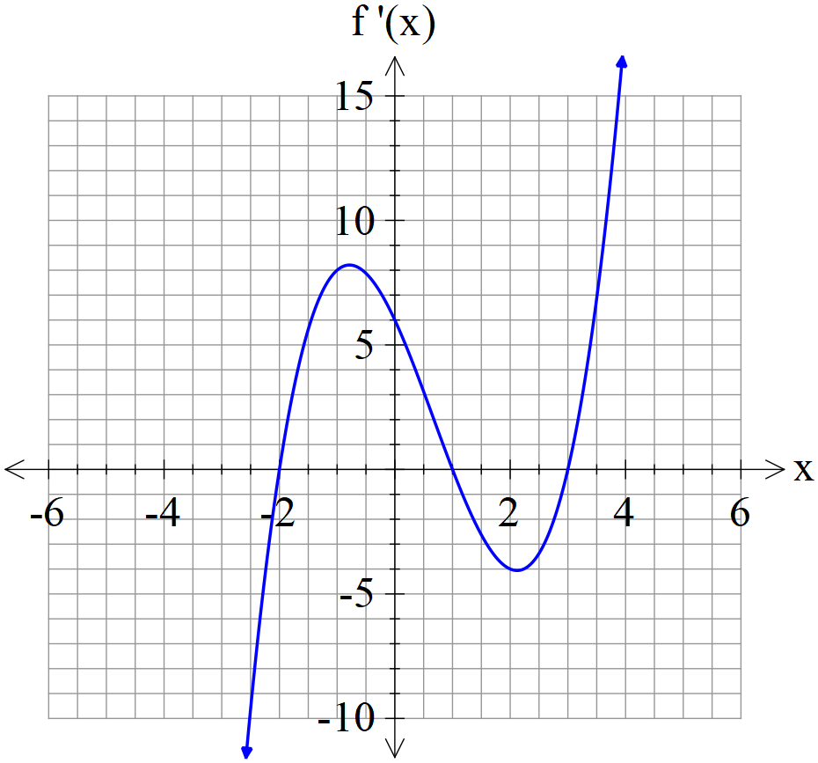
- State the x values of all stationary points of .

- State the nature of each stationary point above and justify.

- State approximate x value for an infection point(s) and explain why.

Q5 (3 & 2 = 5 marks) (3.1.12)
The displacement of a body from the origin O, at time seconds, is metres where

- Determine the time(s) that the velocity is zero metres/second.

- Determine when the acceleration is zero.

Q6 (3 marks) (3.1.10)
The period of a swinging pendulum of length is given by .
Using the increments formula, determine the approximate percentage change in if changes by 3%

.Q7 (4 marks) (3.1.16)
Consider a hollow cylindrical container that has one open end. The surface area of the container is . Determine the exact value of the radius of the closed end that maximises the volume. (Justify)
(Hint- refer to formula sheet)

